GEO 911 RESEARCH METHODOLOGY
LECTURE NOTES

Research: Research comprises defining and redefining problems, formulating hypothesis or suggested solution; collecting, organizing and evaluating data, making deductions and reaching conclusions and carefully testing the conclusions to determine whether they fit the formulating hypothesis. The manipulation of things, concepts or symbols for the purpose of generalizing to extend , correct or verify knowledge, whether that knowledge aids in construction of theory or in the practice of an art.
Research in simple terms refers to search for knowledge. It is a scientific and systematic search for information on a particular topic or issue. It is also known as the art of scientific investigation. Several social scientists have defined research in different ways.
In the Encyclopedia of Social Sciences, D. Slesinger and M. Stephension (1930) defined research as “the manipulation of things, concepts or symbols for the purpose of generalizing to extend, correct or verify knowledge, whether that knowledge aids in the construction of theory or in the practice of an art”.
Research Philosophy
A research philosophy is a belief about the way in which data about a phenomenon should be gathered, analysed and used. The term epistemology (what is known to be true) as opposed to doxology (what is believed to be true) encompasses the various philosophies of research approach. The purpose of science, then, is the process of transforming things believed into things known: doxa to episteme. Two major research philosophies have been identified in the Western tradition of science, namely positivist (sometimes called scientific) and interpretivist (also known as antipositivist) (Galliers, 1991).
Positivism
Positivists believe that reality is stable and can be observed and described from an objective viewpoint (Levin, 1988), i.e. without interfering with the phenomena being studied. They contend that phenomena should be isolated and that observations should be repeatable. This often involves manipulation of reality with variations in only a single independent variable so as to identify regularities in, and to form relationships between, some of the constituent elements of the social world.
Predictions can be made on the basis of the previously observed and explained realities and their inter-relationships. "Positivism has a long and rich historical tradition. It is so embedded in our society that knowledge claims not grounded in positivist thought are simply dismissed as ascientific and therefore invalid" (Hirschheim, 1985, p.33). This view is indirectly supported by Alavi and Carlson (1992) who, in a review of 902 IS research articles, found that all the empirical studies were positivist in approach. Positivism has also had a particularly successful association with the physical and natural sciences.
There has, however, been much debate on the issue of whether or not this positivist paradigm is entirely suitable for the social sciences (Hirschheim, 1985), many authors calling for a more pluralistic attitude towards IS research methodologies (see e.g. Kuhn, 1970; Bjørn-Andersen, 1985; Remenyi and Williams, 1996). While we shall not elaborate on this debate further, it is germane to our study since it is also the case that Information Systems, dealing as it does with the interaction of people and technology, is considered to be of the social sciences rather than the physical sciences (Hirschheim, 1985). Indeed, some of the difficulties
experienced in IS research, such as the apparent inconsistency of results, may be attributed to the inappropriateness of the positivist paradigm for the domain. Likewise, some variables or constituent parts of reality might have been previously thought unmeasurable under the positivist paradigm - and hence went unresearched (after Galliers, 1991).

Interpretivism
Interpretivists contend that only through the subjective interpretation of and intervention in reality can that reality be fully understood. The study of phenomena in their natural environment is key to the interpretivist philosophy, together with the acknowledgement that scientists cannot avoid affecting those phenomena they study. They admit that there may be many interpretations of reality, but maintain that these interpretations are in themselves a part of the scientific knowledge they are pursuing. Interpretivism has a tradition that is no less glorious than that of positivism, nor is it shorter.

Research Methods Vs Methodology:
Research methods include all those techniques/methods that are adopted for conducting research. Thus, research techniques or methods are the methods that the researchers adopt for conducting the research studies. On the other hand, research methodology is the way in which research problems are solved systematically. It is a science of studying how research is conducted scientifically. Under it, the researcher acquaints himself/herself with the various steps generally adopted to study a research problem, along with the underlying logic behind them. Hence, itis not only important for the researcher to know the research techniques/ methods, but also the scientific approach called methodology.
What is the definition of research methodology?
The process used to collect information and data for the purpose of making business decisions. The methodology may include publication research, interviews, surveys and other research techniques, and could include both present and historical information.
Research methodology is a term that basically means the science of how research is done scientifically. It is a way to systematically and logically solve a problem, help us understand the process not just the product of research, and analyzes methods in addition to the information obtained by them.
What are the types of research methodology?
- Basic research
- Applied Research
- Problem oriented research
- Problem solving
- Quantitative Research
- Qualitative Research

Research Problem: A research problem is a statement about an area of concern, a condition to be improved, a difficulty to be eliminated, or a troubling question that exists in scholarly literature, in theory, or in practice that points to the need for meaningful understanding and deliberate investigation.
What is research problem statement?
A problem statement is the description of an issue currently existing which needs to be addressed. It provides the context for the research study and generates the questions which the research aims to answer. The statement of the problem is the focal point of any research.
How do you identify the problem?
Here are seven-steps for an effective problem-solving process.
1. Identify the issues. Be clear about what the problem is.
2. Understand everyone's interests.
3. List the possible solutions (options).
4. Evaluate the options.
5. Select an option or options.
6. Document the agreement(s).
7. Agree on contingencies, monitoring, and evaluation.
Necessity of Defining a Research Problem:
The problem to be researched needs to be described unambiguously as that will help you to discriminate useful data from the unrelated ones. A proper formulation of research problem will allow the investigator to be on the track in contrast to an ill-defined problem may possibly create difficulties.
Questions like: What data are to be gathered? What attributes of data are appropriate and need to be analyzed? What relations should be investigated. What methods should be employed for the purpose? as well as other questions turn up in the head of the investigator who can well plan his strategy and find solutions to these kinds of questions only when the research problem has been well defined. Therefore, defining the problem accurately is a necessity for any research and is a step of the highest value.
In fact, formulation of a problem is often vital than its solution. It is only on thoroughly describing the problem that we can work out the research design and can efficiently proceed all the consequential steps needed while doing research.
Important Points to Keep in Mind while Defining the Research Problem
1. The correct question needs to be addressed if research is to help decision makers. A right answer to the wrong question leads either to bad advice or to no advice.
2. Usually in problem we have an inclination to rationalize and defend our actions once we have started upon a specific research plan. The perfect time to examine and think about alternative techniques is in the planning stage. If it is completed unnecessary expense of false start and redoing work may be prevented.
3. An excellent beginning in problem definition is to ask what the decision maker want to know if the requested information can be gathered without error and without expense.
4. Another excellent rule to follow is “Never settle on a specific strategy” without developing and taking into consideration at least one alternate option”.
5. The problem definition stage of research is the determination and structuring of the decision maker’s question. It should be the decision maker’s question and not the researcher’s question.
6. What decision do you face? Unless you have decision to make, there isn’t any research problem.
7. What are the alternatives? In case there are no options to choose, once again there is absolutely no research problem.
8. What are the factors for selecting the best alternative? Unless you have criteria for
evaluation, again there’s no problem.
9. The researcher should stay away from the acceptance of the superficial and the obvious. Frequently we all hear that a problem clearly expressed is a problem half solved. This statement indicates the necessity of defining a research problem in research methodology . This actually also results in a smoother progress on all the following steps which are needed for finishing a research project.
Types of Research:
There are different types of research. The basic ones are as follows.
Descriptive Versus Analytical:
Descriptive research consists of surveys and fact-finding enquiries of different types. The main objective of descriptive research is describing the state of affairs as it prevails at the time of study. The term ‘ex post facto research’ is quite often used for descriptive research studies in social sciences and business research. The most distinguishing feature of this method is that the researcher has no control over the variables here. He/she has to only report what is happening or what has happened. Majority of the ex post facto research projects are used for descriptive studies in which the researcher attempts to examine phenomena, such as the consumers’ preferences, frequency of purchases, shopping, etc. Despite the inability of the researchers to control the variables, ex post facto studies may also comprise attempts by them to discover the causes of the selected problem. The methods of research adopted in conducting descriptive research are survey methods of all kinds, including correlational and comparative methods.
Meanwhile in the Analytical research, the researcher has to use the already available facts or information, and analyze them to make a critical evaluation of the subject.
Applied Versus Fundamental: Research can also be applied or fundamental in nature. An attempt to find a solution to an immediate problem encountered by a firm, an industry, a business organization, or the society is known as applied research. Researchers engaged in such researches aim at drawing certain conclusions confronting a concrete social or business problem.
On the other hand, fundamental research mainly concerns generalizations and formulation of a theory. In other words, “Gathering knowledge for knowledge’s sake is termed ‘pure’ or ‘basic’ research” (Young in Kothari, 1988). Researches relating to pure mathematics or concerning some natural phenomenon are instances of Fundamental Research. Likewise, studies focusing on human behaviour also fall under the category of fundamental research.
Thus, while the principal objective of applied research is to find a solution to some pressing practical problem, the objective of basic research is to find information with a broad base of application and add to the already existing organized body of scientific knowledge.
Quantitative Versus Qualitative:
Quantitative research relates to aspects that can be quantified or can be expressed in terms of quantity. It involves the measurement of quantity or amount. Various available statistical and econometric methods are adopted for analysis in such research. Which includes correlation, regressions and time series analysis etc,.
On the other hand, Qualitative research is concerned with qualitative phenomena, or more specifically, the aspects related to or involving quality or kind. For example, an important type of qualitative research is ‘Motivation Research’, which investigates into the reasons for certain human behaviour. The main aim of this type of research is discovering the underlying motives and desires of human beings by usingin-depth interviews. The other techniques employed in such research are story completion tests, sentence completion tests, word association tests, and other similar projective methods. Qualitative research is particularly significant in the context of behavioural sciences, which aim at discovering the underlying motives of human behaviour. Such research helps to analyse the various factors that motivate human beings to behave in a certain manner, besides contributing to an understanding of what makes individuals like or dislike a particular thing. However, it is worth noting that conducting qualitative research in practice is considerably a difficult task. Hence, while undertaking such research, seeking guidance from experienced expert researchers is important.
Conceptual Versus Empirical:
The research related to some abstract idea or theory is known as Conceptual Research. Generally, philosophers and thinkers use it for developing new concepts or for reinterpreting the existing ones. Empirical Research, on the other hand, exclusively relies on the observation or experience with hardly any regard for theory and system. Such research is data based, which often comes up with conclusions that can be verified through experiments or observation. Empirical research is also known as experimental type of research, in which it is important to first collect the facts and their sources, and actively take steps to stimulate the production of desired information. In this type of research, the researcher first formulates a working hypothesis, and then gathers sufficient facts to prove or disprove the stated hypothesis. He/she formulates the experimental design, which according to him/her would manipulate the variables, so as to obtain the desired information. This type of research is thus characterized by th e researcher’s control over the variables under study. In simple term, empirical research is most appropriate when an attempt is made to prove that certain variables influence the other variables in some way. Therefore, the results obtained by using the experimental or empirical studies are considered to be the most powerful evidences for a given hypothesis.
Other Types of Research:
The remaining types of research are variations of one or more type of research. They vary in terms of the purpose of research, or the time required to complete it, or may be based on some other similar factor. On the basis of time, research may either be in the nature of one -time or longitudinal time series research. While the research is restricted to a single time-period in the former case, it is conducted over several time-periods in the latter case. Depending upon the environment in which the research is to be conducted, it can also be laboratory research or field - setting research, or simulation research, besides being diagnostic or clinical in nature. Under such research, in-depth approaches or case study method may be employed to analyse the basic causal relations. These studies usually undertake a detailed in-depth analysis of the causes of certain events of interest, and use very small samples and sharp data collection methods. The research may also be explanatory in nature. Formalized research studies consist of substantial structure and specific hypotheses to be verified. As regards to historical research, sources like historical documents, remains, etc. Are utilized to study past events or ideas. It also includes philosophy of persons and groups of the past or any remote point of time.
Research has also been classified into decision-oriented and conclusion-oriented categories. The decision-oriented research is always carried out as per the need of a decision maker and hence, the researcher has no freedom to conduct the research according to his/her own desires. On the other hand, in the case of Conclusion-oriented research, the researcher is free to choose the problem, redesign the enquiry as it progresses and even change conceptualization as he/she wishes to. An operation research is a kind of decision-oriented research, where in scientific method is used in providing the departments, a quantitative basis for decision -making with respect to the activities under their purview.
Steps in Research Process
Research process contains a series of closely related activities which has to carry out by a researcher. Research process requires patients. There is no measure that shows your research is the best. It is an art rather than a science. Following are the main steps in social or business research process.
1. Selection of Research Problem
2. Extensive Literature Survey
3. Making Hypothesis
4. Preparing the Research Design
5. Sampling
6. Data collection
7. Data Analysis
8. Hypothesis Testing
9. Generalization and Interpretation
10. Preparation of Report
Selection of Research Problem
The selection of topic for research is a difficult job. When we select a title or research statement, then other activities would be easy to perform. So, for the understanding thoroughly the problem it must have to discuss with colleagues, friend, experts and teachers. The research topic or problem should be practical, relatively important, feasible, ethically and politically acceptable.
Literature Review or Extensive Literature Survey
After the selection of research problem, the second step is that of literature mostly connected with the topics. The availability of the literature may bring ease in the research. For this purpose academic journals, conference and govt. reports and library must be studied. Making Hypothesis
The development of hypothesis is a technical work depends on the researcher experience. The hypothesis is to draw the positive & negative cause and effect aspects of a problem. Hypothesis narrows down the area of a research and keep a researcher on the right path.
Preparing the Research Design
After the formulation of the problem and creating hypothesis for it, research Design is to prepare by the researcher. It may draw the conceptual structure of the problem. Any type of research design may be made, depend on the nature and purpose of the study. Daring R. Design the information about sources, skill, time and finance is taken into consideration.
Sampling
The researcher must design a sample. It is a plan for taking its respondents from a specific areas or universe. The sample may be of two types:
1. Probability Sampling
2. Non-probability Sampling
Data collection
Data collection is the most important work, is researcher. The collection of information must be containing on facts which is from the following two types of researcher.
Primary Data Collection: Primary data may be from the following.
1. Experiment
2. Questionnaire
3. Observation
4. Interview
Secondary data collection: it has the following categories:
1. Review of literature
2. Official and non-official reports
3. Library approach
Data Analysis
When data is collected, it is forwarded for analysis which is the most technical job. Data analysis may be divided into two main categories.
Data Processing: it is sub-divided into the following.
Data editing, Data coding, Data classification, Data tabulation, Data presentation, Data measurement
Data Exposition: Date Exposition has the following sub-categories.
Description, Explanation, Narration, Conclusion/Findings, Recommendations/Suggestions
Hypothesis Testing
Research data is then forwarded to test the hypothesis. Do the hypothesis are related to the f acts or not? To find the answer the process of testing hypothesis is undertaken which may result in accepting or rejecting the hypothesis.
Generalization and Interpretation
The acceptable hypothesis is possible for researcher to arrival at the process of generalization or to make & theory. Some types of research has no hypothesis for which researcher depends upon on theory which is known as interpretation.
Preparation of Report
A researcher should prepare a report for which he has done is his work. He must keep in his mind the following points:
Report Design in Primary Stages
The report should carry a title, brief introduction of the problem and background followed by acknowledgement. There should be a table of contents, grapes and charts.
Main Text of the Report
It should contain objectives, hypothesis, explanations and methodology of the research. It must be divided into chapters and every chapter explains separate title in which summary of the findings should be enlisted. The last section would be clearly of conclusions to show the main theme of the R-study.
Closing the Report
After the preparation of report, the last step in business research process contains of bibliography, references, appendices, index and maps or charts for illustration. For this purpose the information should more clearer.
Ethics in Business Research
Ethics are norms or standards of behavior that guide moral choices about our behavior and our relationship with others.
As in other aspects of business, all parties in research should exhibit ethical behavior.
The goal of ethics in research is to ensure that no one is harmed or suffered adverse consequences from research activities.
However, unethical activities are pervasive and include violating non-disclosure agreement, breaking respondent confidentiality, misrepresenting results, deceiving people, invoicing irregularities, avoiding legal liability, and more.
⚫ As research is designed, several ethical considerations must be balanced:
⚫ Protect the rights of the participant or subject.
⚫ Ensure the sponsor receives ethically conducted and reported research
⚫ Follow ethical standards when designing research
⚫ Protect the safety of the researcher and team
⚫ In general, research must be designed so a respondent does not suffer physical harm, discomfort, pain, embarrassment, or loss of privacy. Begin data collection by explaining to respondent the benefits expected from the research.
⚫ Explain that their rights and well-being will be adequately protected and say how that
will be done. Be certain that interviewers obtain in the inform consent of the respondent. The use of deception is questionable; when it is used, debrief any respondent who has been deceived.
Limitations of Social Science Research
⚫ The question of objectivity has been central to the methodological debates of the social sciences from the beginning. It means the willingness and ability to examine evidence dispassionately. It is the first condition of research.

Limits of social science
a) Social scientist is part of human society and their judgments are subjective and coloured by researchers own experience.
b) The subject matter of social science research is too complex. All propositions are limited particular social groups and contexts.
c) All members of the society have different values, social researcher will unconsciously influenced by their values.
d) Social scientist fails to achieve objectivity because the respondents are human beings have certain human problems. e.g. refusal of respondent, improper understanding, reluctance etc,. All these problems cause biases and invalidate the research findings and conclusions.

Data Collection Methods and Tools
Data collection is a process of collecting information from all the relevant sources to find answers to the research problem, test the hypothesis and evaluate the outcomes.
Data collection methods can be divided into two categories: primary methods of data
collection. And secondary methods of data collection
Primary Data Collection Methods
Primary data collection methods can be divided into two groups: quantitative and qualitative. Quantitative are based in mathematical calculations in various formats. Methods of quan titative data collection and analysis include questionnaires with closed-ended questions, methods of correlation and regression, mean, mode and median and others.
⚫ Qualitative, on the contrary, do not involve numbers or mathematical calculations.
Qualitative research is closely associated with words, sounds, feeling, emotions, colors and other elements that are non-quantifiable.
⚫ Qualitative studies aim to ensure greater level of depth of understanding and qualitative
data collection methods include interviews, questionnaires with open-ended questions, focus groups, observation, game or role-playing, case studies etc.
Data Collection Techniques
Step 1: Identify issues and/or opportunities for collecting
Step 2: Select issue(s) and/or opportunities and set
Step 3: Plan an approach and methods
Step 4: Collect data
Step 5: Act on results
Information you gather can come from a range of sources. Likewise, there are a variety of techniques to use when gathering primary data. Listed below are some of the most common data collection techniques.
⚫ Interviews
⚫ Questionnaires and Surveys
⚫ Observations
⚫ Focus Groups
⚫ Documents and Records

Technique | Key Facts | Example
Interviews | • Interviews can be conducted in person or over the telephone  • Interviews can be done formally (structured), semi-structured, or informally  • Questions should be focused, clear, and encourage open-ended responses  • Interviews are mainly qualitative in nature | One-on-one conversation with parent of at-risk youth who can help you understand the issue
Questionnaires and Surveys | • Responses can be analyzed with quantitative methods by assigning numerical values to Likert-type scales  • Results are generally easier (than qualitative techniques) to analyze  • Pretest/Posttest can be compared and analyzed | Results of a satisfaction survey or opinion survey
Documents and Records | • Consists of examining existing data in the form of databases, meeting minutes, reports, attendance logs, financial records, newsletters, etc.  • This can be an inexpensive way to gather information but may be an incomplete data source | To understand the primary reasons students miss school, records on student absences are collected
Designing questionnaire and schedule of questions
Questionnaire: A questionnaire refers to a device for securing answers to questions by using a form which the respondent fills in by himself/herself. It consists of some questions printed or typed in a definite order.
People quite commonly use questionnaire and schedule interchangeably, due to much resemblance in their nature; however, there are many differences between these two.
While a questionnaire is filled by the informants themselves, enumerators fill schedule
on behalf of the respondent.
Definition of Schedule
The schedule is a proforma which contains a list of questions filled by the research workers or enumerators, specially appointed for the purpose of data collection.
Enumerators go to the informants with the schedule, and ask them the questions from the set, in the sequence and record the replies in the space provided.
There are certain situations, where the schedule is distributed to the respondents, and the enumerators assist them in answering the questions.
Key Differences Between Questionnaire and Schedule
⚫ Questionnaire refers to a technique of data collection which consist of a series of written questions along with alternative answers. The schedule is a formalized set of questions, statements, and spaces for answers, provided to the enumerators who ask questions to the respondents and note down the answers.
⚫ Questionnaires are delivered to the informants by post or mail and answered as specified in the cover letter. On the other hand, schedules are filled by the research workers, who interpret the questions to the respondents if necessary.
⚫ The response rate is low in case of questionnaires as many people do not respond and often return it without answering all the questions. On the contrary, the response rate is high, as they are filled by the enumerators, who can get answers to all the question.
⚫ The questionnaires can be distributed a large number of people at the same time, and
even the respondents who are not approachable can also be reached easily. Conversely, in schedule method, the reach is relatively small, as the enumerators cannot be sent to a large area.
⚫ Data collection by questionnaire method is comparatively cheaper and economical as the
money is invested only in the preparation and posting of the questionnaire. As against this, a large amount is spent on the appointment and training of the enumerators and also on the preparation of schedules.
⚫ In questionnaire method, it is not known that who answers the question whereas, in the
case of schedule, the respondent’s identity is known.
⚫ The success of the questionnaire lies on the quality of the questionnaire while the honesty and competency of the enumerator determine the success of a schedule.
⚫ The questionnaire is usually employed only when the respondents literate and cooperative. Unlike schedule which can be used for data collection from all classes of people.

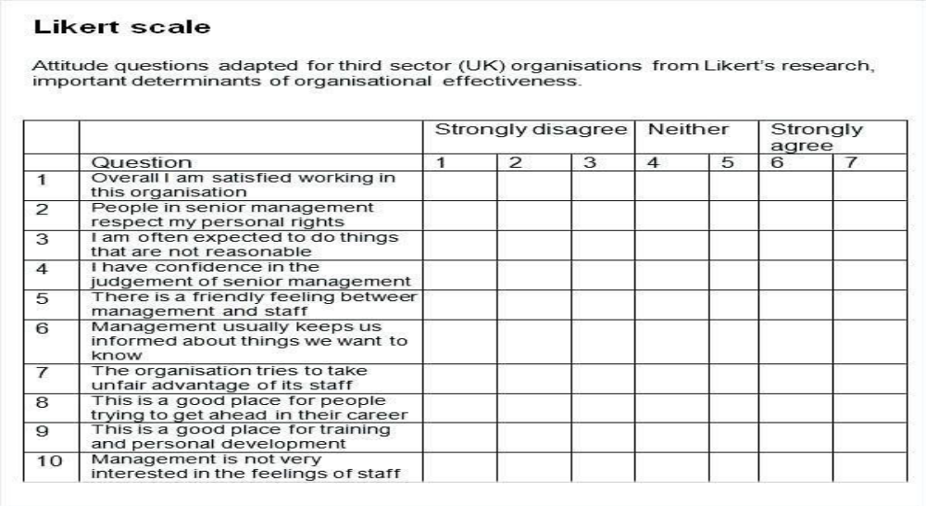
Construction of Questionnaire
- Problem identification
- Search for relevant secondary data for problem
- Exploratory interviews with subject expertise and review personal experience with colleagues
- Writing of specific research objectives
- Listing of hypothesis to be tested
- Development of questions for questionnaire

Characteristics of a good questionnaire
- Deals with a significant topic
- Seeks only that information which cannot be obtained from other sources such as census data
- As short as possible, only long enough to get the essential data.
- Attractive in appearance, neatly arranged, and clearly duplicated or printed.
- Directions are clear and complete. Questions are objective, with no leading suggestions to the desired response
- Questions are presented in good psychological order, proceeding from general to more specific responses.
- To easy tabulate and interpret.

Guidelines for preparing questionnaire
• Prepared according with study objective
• Concise, precise and brief
• Criticism from faculty and class members
• Trailing the questionnaire with friends

• Respondents selected carefully
• As par as possible open ended questions should be avoided
• Controversial and ambiguous questions should be avoided
• Getting permission in organization before administering questionnaire
• Try to get the aid of sponsorship
• Mailed questionnaire should have introduction, purpose and directions to fill the questions
• Abrupt ending of the questions and questionnaire should be avoided.
Sampling Methods
Sampling is a process used in statistical analysis in which a predetermined number of observations are taken from a larger population.
Sampling helps a lot in research. It is one of the most important factors which determines the accuracy of your research/survey result. If anything goes wrong with your sample then it will be directly reflected in the final result.
Sample is the subset of the population. The process of selecting a sample is known as sampling. Number of elements in the sample is the sample size.



There are lot of sampling techniques which are grouped into two categories as
⚫ Probability Sampling
⚫ Non- Probability Sampling

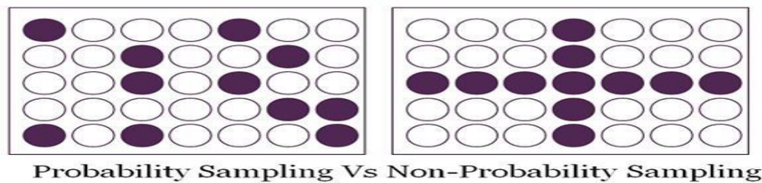
Probability Sampling

⚫ This Sampling technique uses randomization to make sure that every element of the population gets an equal chance to be part of the selected sample. It’s alternatively known as random sampling.
⚫ Simple Random Sampling
⚫ Stratified sampling
⚫ Systematic sampling
⚫ Cluster Sampling

Simple Random Sampling: Every element has an equal chance of getting selected to be the part
sample. It is used when we don’t have any kind of prior information about the target population.
⚫ For example: Random selection of 20 students from class of 50 student. Each student has equal chance of getting selected. Here probability of selection is 1/50

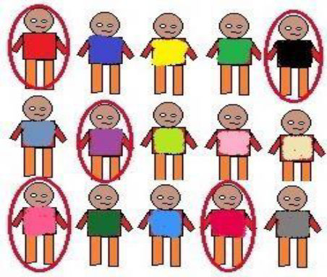

Stratified Sampling
This technique divides the elements of the population into small subgroups (strata) based on the similarity in such a way that the elements within the group are homogeneous and heterogeneous among the other subgroups formed. And then the elements are randomly selected from each of these strata. We need to have prior information about the population to create subgroups.
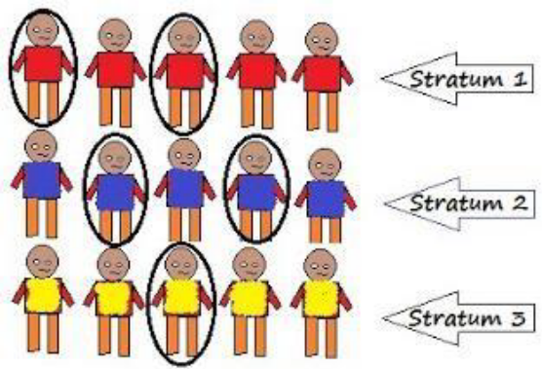

Cluster Sampling
⚫ Our entire population is divided into clusters or sections and then the clusters are randomly selected. All the elements of the cluster are used for sampling. Clusters are identified using details such as age, sex, location etc.
⚫ Cluster sampling can be done in following ways:

Single Stage Cluster Sampling
⚫ Entire cluster is selected randomly for sampling.

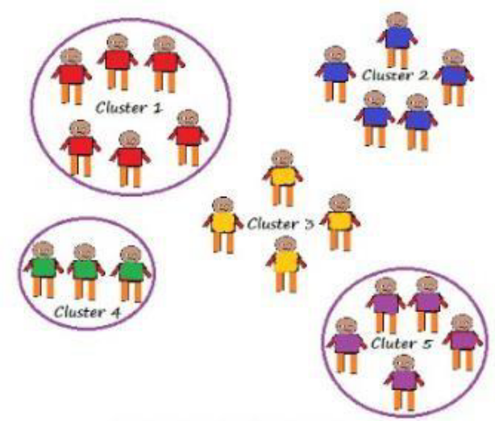Non-Probability Sampling

It does not rely on randomization. This technique is more reliant on the researcher’s ability to
select elements for a sample. This type of sampling is also known as non-random sampling.
⚫ Convenience Sampling
⚫ Purposive Sampling
⚫ Quota Sampling
⚫ Referral /Snowball Sampling

Convenience Sampling
⚫ Here the samples are selected based on the availability. This method is used when the availability of sample is rare and also costly. So based on the convenience samples are selected.

For example: Researchers prefer this during the initial stages of survey research, as it’s quick
and easy to deliver results.
Purposive Sampling
⚫ This is based on the intention or the purpose of study. Only those elements will be selected from the population which suits the best for the purpose of our study.
⚫ For Example: If we want to understand the thought process of the people who are interested in pursuing master’s degree then the selection criteria would be “Are you interested for Masters in..?”

All the people who respond with a “No” will be excluded from our sample.
Quota Sampling
⚫ This type of sampling depends of some pre-set standard. It selects the representative sample from the population. Proportion of characteristics/ trait in sample should be same as population. Elements are selected until exact proportions of certain types of data is obtained or sufficient data in different categories is collected.
⚫ For example: If our population has 45% females and 55% males then our sample should

reflect the same percentage of males and females.
Referral /Snowball Sampling
⚫ This technique is used in the situations where the population is completely unknown and rare.
⚫ Therefore we will take the help from the first element which we select for the population and ask him to recommend other elements who will fit the description of the sample needed.
⚫ So this referral technique goes on, increasing the size of population like a snowball. Eg-
Chronic Diseases

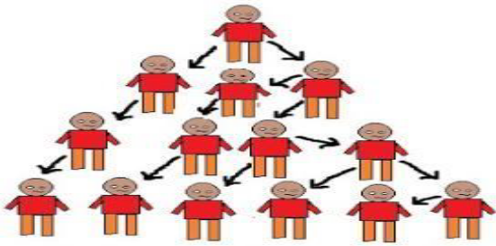

Tabulating is a way of processing information or data by putting it in a table. This doesn't mean the kind of table you eat off of, though. It refers to a table, or chart, with rows and columns . When tabulating, you might have to make calculations.
What is simple tabulation?
⚫ The process of placing classified data into tabular form is known as tabulation. A table is a symmetric arrangement of statistical data in rows and columns. Rows are horizon tal arrangements whereas columns are vertical arrangements. It may be simple, double or complex depending upon the type of classification.
Interpretation of Data: Data analysis and interpretation is the process of assigning meaning to the collected information and determining the conclusions, significance, and implications of the findings.
What is the significance of data interpretation?
⚫ Data interpretation refers to the process of critiquing and determining the significance of important information, such as survey results, experimental findings, observations or narrative reports. Interpreting data is an important critical thinking skill that helps you comprehend text books, graphs and tables.
The varying scales include:
⚫ Nominal Scale: non-numeric categories that cannot be ranked or compared quantitatively. Variables are exclusive and exhaustive.
⚫ Ordinal Scale: exclusive categories that are exclusive and exhaustive but with a logical order. Quality ratings and agreement ratings are examples of ordinal scales (i.e., good, very good, fair, etc., OR agree, strongly agree,
⚫ disagree, etc.).
⚫ Interval: a measurement scale where data is grouped into categories with orderly and equal distances between the categories. There is always an arbitrary zero point.
⚫ Ratio: contains features of all three.
Qualitative Data Interpretation
⚫ Qualitative data analysis can be summed up in one word – categorical. With qualitative analysis, data is not described through numerical values or patterns, but through the use of descriptive context (i.e., text). These techniques include:
⚫ Observations: detailing behavioral patterns that occur within an observation group.
⚫ Documents: much like how patterns of behavior can be observed, different types of documentation resources can be coded and divided based on the type of material they contain.
⚫ Interviews: one of the best collection methods for narrative data. Enquiry responses can
be grouped by theme, topic or category.
Quantitative Data Interpretation
⚫ More often than not, it involves the use of statistical modeling such as standard deviation,
mean and median. Let’s quickly review the most common statistical terms:
⚫ Mean: a mean represents a numerical average for a set of responses. When dealing with a data set (or multiple data sets), a mean will represent a central value of a specific set of numbers.
⚫ Standard deviation: Standard deviation reveals the distribution of the responses around
the mean. It describes the degree of consistency within the responses;
⚫ Frequency distribution: When using a survey, for example, frequency distribution has the capability of determining the number of times a specific ordinal scale response appears (i.e., agree, strongly agree, disagree, etc.). Frequency distribution is extremely keen in determining the degree of consensus among data points.

What is the meaning of data analysis in research?
⚫ The process of evaluating data using analytical and logical reasoning to examine each component of the data provided. Data from various sources is gathered, reviewed, and then analyzed to form some sort of finding or conclusion.
Levels of Measurement Scales
The level of measurement refers to the relationship among the values that are assigned to the attributes, feelings or opinions for a variable.
Typically, there are four levels of measurement scales or methods of assigning numbers:
(a) Nominal scale,
(b) Ordinal scale,
(c) Interval scale, and
(d) Ratio scale.

Nominal Scale is the crudest among all measurement scales but it is also the simplest scale. In this scale the different scores on a measurement simply indicate different categories. The nominal scale does not express any values or relationships between variables.
Example: Let’s start with the easiest one to understand. Nominal scales are used for labeling variables, without any quantitative value. “Nominal” scales could simply be called “labels.” Here are some examples, below. Notice that all of these scales are mutually exclusive (no overlap) and none of them have any numerical significance. A good way to remember all of this is that “nominal” sounds a lot like “name” and nominal scales are kind of like “names” or labels.
Ordinal Scale involves the ranking of items along the continuum of the characteristic being scaled. In this scale, the items are classified according to whether they have more or less of a characteristic.
The main characteristic of the ordinal scale is that the categories have a logical or ordered relationship. This type of scale permits the measurement of degrees of difference,(i.e. ‘more’ or ‘less’) but not the specific amount of differences (i.e. how much ‘more’ or ‘less’).
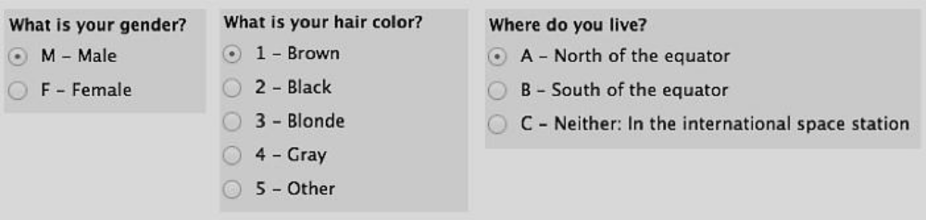

Comparitives Scales : In comparative scaling, the respondent is asked to compare one object with another. The comparative scales can further be divided into the following four types of scaling techniques:
(a) Paired Comparison Scale,
(b) Rank Order Scale,
(c) Constant Sum Scale, and
(d) Q-sort Scale.
Paired Comparison Scale: This is a comparative scaling technique in which a respondent is presented with two objects at a time and asked to select one object according to some criterion. The data obtained are ordinal in nature.
For example, there are four types of cold drinks -
Coke, Pepsi, Sprite, and Limca. The respondents can prefer Pepsi to Coke or Coke to Sprite, etc.
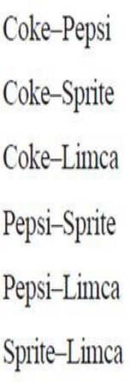
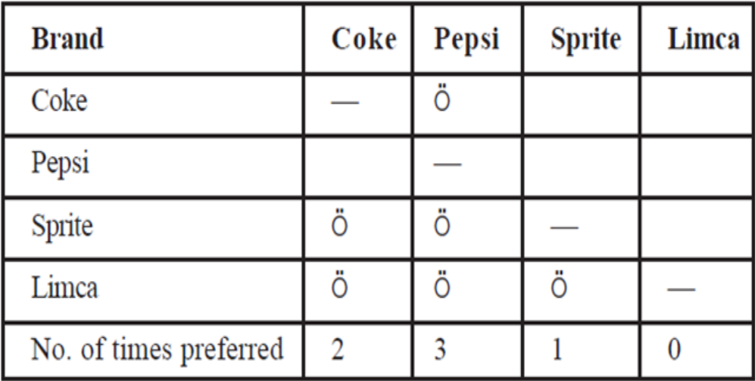
Rank Order Scale: This is another type of comparative scaling technique in which respondents are presented with several items simultaneously and asked to rank them in the order of priority. This is an ordinal scale that describes the favoured and un favoured objects, but does not reveal the distance between the objects.
The resultant data in rank order is ordinal data. This yields better results when direct comparison is required between the given objects.
The major disadvantage of this technique is that only ordinal data can be generated.

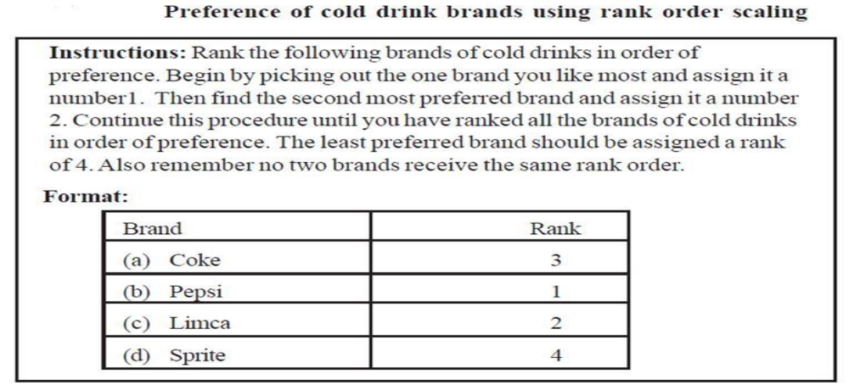
Constant Sum Scale: In this scale, the respondents are asked to allocate a constant sum of units such as points, rupees, or chips among a set of stimulus objects with respect to some criterion.
For example, you may wish to determine how important the attributes of price, fragrance,
packaging, cleaning power, and lather of a detergent are to consumers. Respondents might be asked to divide a constant sum to indicate the relative importance of the attributes.
The advantage of this technique is saving time. However, main disadvantages are the respondents may allocate more or fewer points than those specified. The second problem is respondents might be confused.
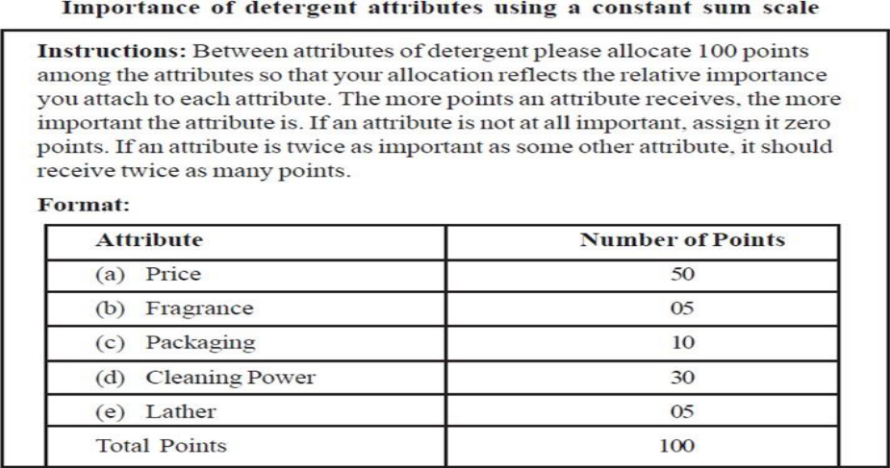

Q-Sort Scale:
This is a comparative scale that uses a rank order procedure to sort objects based on similarity with respect to some criterion. The important characteristic of this methodology is that it is more important to make comparisons among different responses of a respondent than the responses between different respondents.
Therefore, it is a comparative method of scaling rather than an absolute rating scale. In this method the respondent is given statements in a large number for describing the characteristics of a product or a large number of brands of a product.
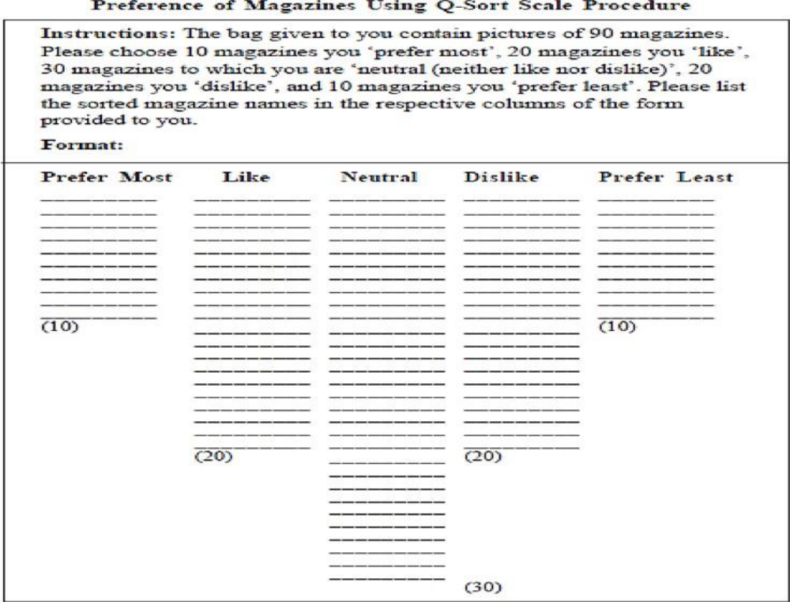
NON-COMPARITIVE SCALES
In non-comparative scaling respondents need only evaluate a single object. Their evaluation is independent of the other object which the researcher is studying.
The non-comparative scaling techniques can be further divided into:
(a) Continuous Rating Scale, and
(b) Itemized Rating Scale.
Continuous Rating Scales: It is very simple and highly useful. In continuous rating scale, the respondent’s rate the objects by placing a mark at the appropriate position on a continuous line that runs from one extreme of the criterion variable to the other.
Example: Question: How would you rate the TV advertisement as a guide for buying?
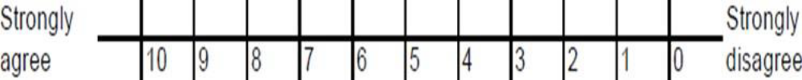
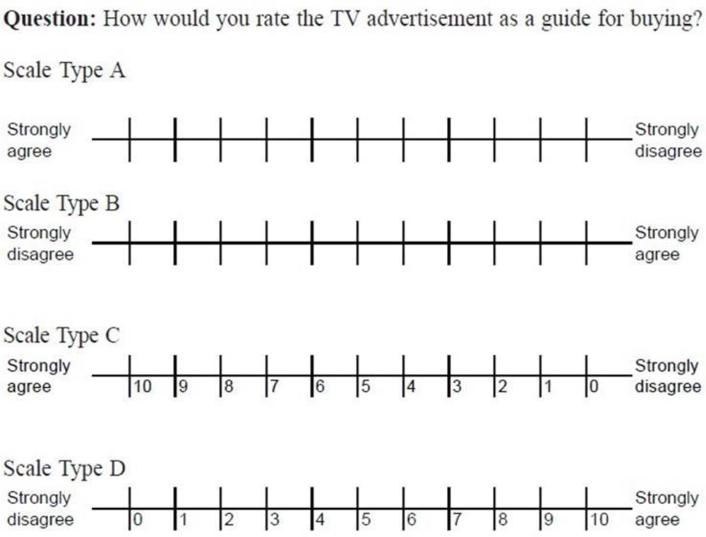
Itemized Rating Scales:
Itemized rating scale is a scale having numbers or brief descriptions associated with each category. The categories are ordered in terms of scale position and the respondents are required to select one of the limited numbers of categories that best describes the product, brand, company, or product attribute being rated. Itemized rating scales are widely used in marketing research.
Itemized rating scales is further divided into three parts, namely
(a) Likert scale,
(b) Semantic Differential Scale, and
(c) Stapel Scale.
The itemized rating scales can be in the form of: (a) graphic, (b) verbal, or (c) numeric as shown below :
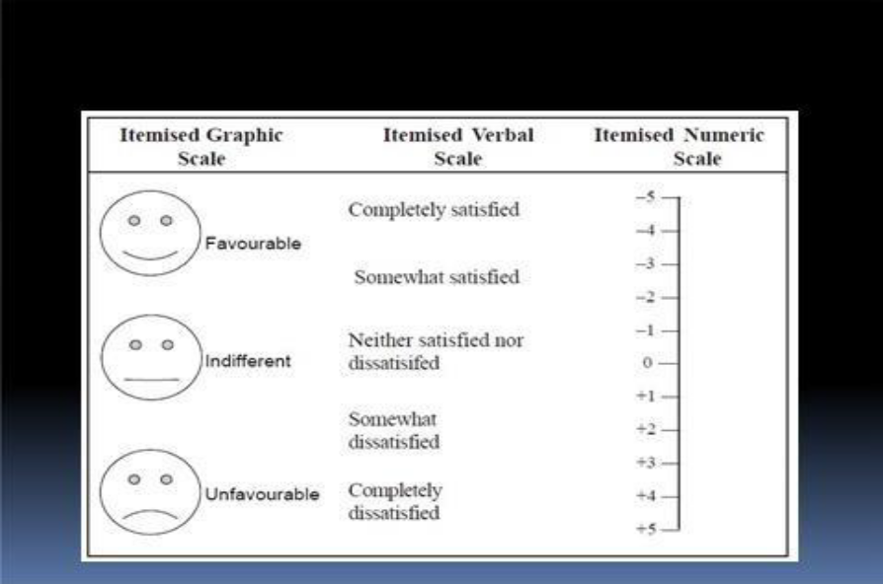
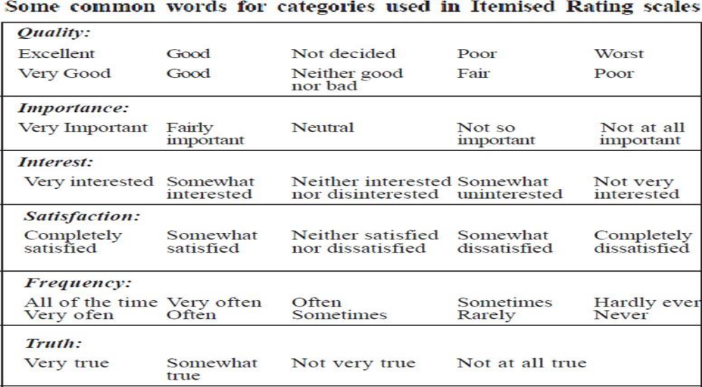

Likert Scale:
Likert, is extremely popular for measuring attitudes, because, the method is simple to administer. With the Likert scale, the respondents indicate their own attitudes by checking how strongly they agree or disagree with carefully worded statements that range from very positive to very negative towards the attitudinal
Object. Respondents generally choose from five alternatives (say strongly agree, agree, neither agree nor disagree, disagree, strongly disagree).
A Likert scale may include a number of items or statements. Disadvantage of Likert Scale is that it takes longer time to complete than other itemised rating scales because respondents have to read each statement.
Despite the above disadvantages, this scale has several advantages. It is easy to construct, administer and use.
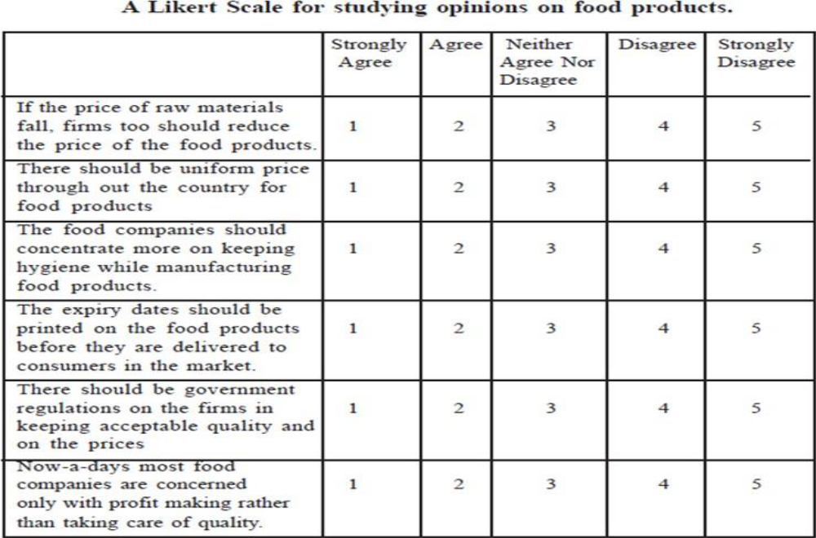

Semantic Differential Scale: This is a seven point rating scale with end points associated with bipolar labels (such as good and bad, complex and simple) that have semantic meaning. It can be used to find whether a respondent has a positive or negative attitude towards an object. It has been widely used in comparing brands, products and company images. It has also been used to develop advertising and promotion strategies and in a new product development study.
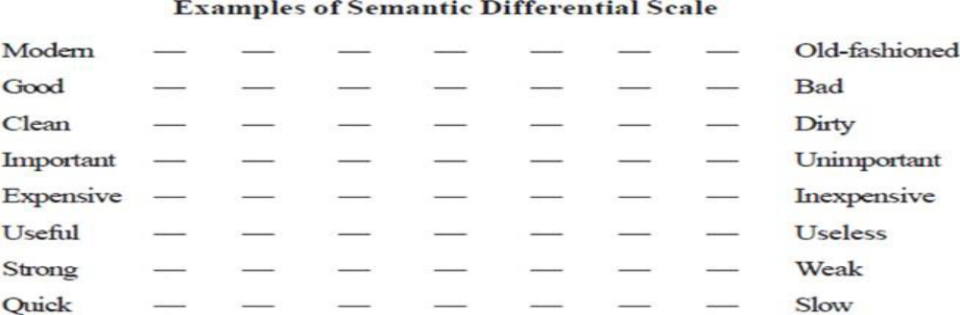

Sources of Error in Measurement
Measurement should be precise and unambiguous in an ideal research study. This objective, however, is often not met with in entirety. As such the researcher must be aware about the sources of error in measurement. The following are the possible sources of error in measurement. Respondent: At times the respondent may be reluctant to express strong negative feelings or it is just possible that he may have very little knowledge but may not admit his ignorance. All this reluctance is likely to result in an interview of ‘guesses.’ Transient factors like fatigue, boredom, anxiety, etc. may limit the ability of the respondent to respond accurately and fully.
Situation: Situational factors may also come in the way of correct measurement. Any condition which places a strain on interview can have serious effects on the interviewer-respondent rapport. For instance, if someone else is present, he can distort responses by joining in or merely by being present. If the respondent feels that anonymity is not assured, he may be reluctant to express certain feelings.
Measurer: The interviewer can distort responses by rewording or reordering questions. His behavior, style and looks may encourage or discourage certain replies from respondents. Careless mechanical processing may distort the findings. Errors may also creep in because of incorrect coding, faulty tabulation and/or statistical calculations, particularly in the data-analysis stage.
Instrument: Error may arise because of the defective measuring instrument. The use of complex words, beyond the comprehension of the respondent, ambiguous meanings, poor printing, inadequate space for replies, response choice omissions, etc. are a few things that make the measuring instrument defective and may result in measurement errors. Another type of instrument deficiency is the poor sampling of the universe of items of concern. Researcher must know that correct measurement depends on successfully meeting all of the problems listed above. He must, to the extent possible, try to eliminate, neutralize or otherwise deal with all the possible sources of error so that the final results may not be contaminated.
GUIDELINES FOR DECIDING SCALES
A number of issues decide the choice of scaling technique. Some significant issues are:
1) Problem Definition and Statistical Analysis,
2) The Choice between Comparative and Non-comparative Scales,
3) Type of Category Labels,
4) Number of Categories,
5) Balanced versus Unbalanced Scale, and
6) Forced versus Non-forced Categories
Research Design: The most important step after defining the research problem is pre design of the research project, which is popularly known as the ‘research design’. A research design helps to decide upon issues like what, when, where, how much, by what means etc. With regard to an enquiry or a research study a research design is the arrangement of conditions f or collection and analysis of data in a manner that aims to combine relevance to the research purpose with economy in procedure. In fact, research design is the conceptual structure wit hin which research is conducted; it constitutes the blueprint for the collection, measurement and analysis of data (Selltiz et al, 1962). Thus, research design provides an outline of what the researcher is going to do in terms of framing the hypothesis, its operational implications and the final data analysis. Specifically, the research design highlights decisions which include:
- The nature of the study
- The purpose of the study
- The location where the study would be conducted
- The nature of data required
- From where the required data can be collected
- What time period the study would cover
- The type of sample design that would be used
- The techniques of data collection that would be used
- The methods of data analysis that would be adopted and
- The manner in which the report would be prepared

What is Research Design?
- A framework or blueprint for conducting the Major research project.
- Specifies the details of the procedures necessary for obtaining information needed to structure or solve the Major research problem.
- A research design lays the foundation for conducting the research.
- Task of defining the research problem is the preparation of the research project, popularly known as the “research design".

Decisions regarding what, where, when, how much, by what means concerning an inquiry or a research study constitute a research design.
Meaning of research design-
A research design is the arrangement of conditions for collection and analysis of data in a manner that aims to combine relevance to the research purpose with economy in procedure.
Research design has following parts:
- Sampling design
- Observational design
- Statistical design
- Operational design

Sampling design: Which deals with the methods of selecting items to be observed for the study. Observational design: Which relates to the condition under which the observation are to be create.
Statistical design: Which concern the question of the of How the information and data gathered are to be analyzed ?
Operational design: Which deals with techniques by which the procedures satisfied in sampling
Features of a good research design
- A research design appropriate for a particular research problem, usually involves the following features.
- The mean of obtaining information.
- The availability and skills of the researcher and his staff, if any.
- The objective of the problem to be studied. The nature of the problem to be studied.
- The availability of time and money for the research work.

Components of Research Design
- Design the exploratory, descriptive & or causal phases of the research.
- Define the information needed.
- Specify the measurement &scaling procedures.
- Construct & pretest a questionnaire for data collection.
- Specify the sampling process & sample size.
- Develop a plan of data analysis.

Research Vs Quantitative Research Qualitative Research

Qualitative Research | Quantitative Research
Qualitative Research is primarily exploratory research. It is used to gain an understanding of underlying reasons, opinions, and motivations. | Quantitative Research is used to quantify the problem by way of generating numerical data or data that can be transformed into usable statistics.
It provides insights into the problem or helps to develop ideas or hypotheses for potential quantitative research. | It is used to quantify attitudes, opinions, behaviors, and other defined variables – and generalize results from a larger sample
Qualitative Research is also used to uncover trends in thought and opinions, and dive deeper into the problem. Qualitative data collection methods vary using unstructured or semi-structured techniques. | Quantitative Research uses measurable data to formulate facts and uncover patterns in research.
Some common methods include focus groups (group discussions), individual interviews, and participation/observations. | Quantitative data collection methods are much more structured than Qualitative data collection methods.
The sample size is typically small, and respondents are selected to fulfill a given quota. | Quantitative data collection methods include various forms of surveys – online surveys, paper surveys, mobile surveys and kiosk surveys, face- to-face interviews, telephone interviews, longitudinal studies, website interceptors, online polls, and systematic observations.

Types of Research Design
There are different types of research designs. They may be broadly categorized as:
- Exploratory Research Design;
- Descriptive and Diagnostic Research Design; and
- Hypothesis-Testing Research Design.
Exploratory Research Design:
The Exploratory Research Design is known as formulative research design. The main objective of using such a research design is to formulate a research problem for an in -depth or more precise investigation, or for developing a working hypothesis from an ope rational aspect. The major purpose of such studies is the discovery of ideas and insights. Therefore, such a research design suitable for such a study should be flexible enough to provide opportunity for considering different dimensions of the problemunder study. The in-built flexibility in research design is required as the initial research problem would be transformed into a more precise one in the exploratory study, which in turn may necessitate changes in the research procedure for collecting relevant data. Usually, the following three methods are considered in the context of a research design for such studies. They are (a) a survey of related literature; (b) experience survey; and (c) analysis of ‘insight-stimulating’ instances.
2. Descriptive and Diagnostic Research Design:
A Descriptive Research Design is concerned with describing the characteristics of a particular individual or a group. Meanwhile, a diagnostic research design determines the frequency with which a variable occurs or its relationship with another variable. In other words, the study analyzing whether a certain variable is associated with another comprises a diagnostic research study. On the other hand, a study that is concerned with specific predictions or with the narration of facts and characteristics related to an individual, group or situation, are instances of descriptive research studies. Generally, most of the social research design falls under this category. As a research design, both the descriptive and diagnostic studies share c ommon requirements, hence they are grouped together. However, the procedure to be used and the research design need to planned carefully. The research design must also make appropriate provision for protection against bias and thus maximize reliability, with due regard to the completion of the research study in an economical manner. The research design in such studies should be rigid and not flexible. Besides, it must also focus attention on the following:
- Formulation of the objectives of the study,
- Proper designing of the methods of data collection,
- Sample selection,
- Data collection,
- Processing and analysis of the collected data, and
- Reporting the findings
3. Hypothesis-Testing Research Design: Hypothesis-Testing Research Designs are those in which the researcher tests the hypothesis of causal relationship between two or more variables. These studies require procedures that would not only decrease bias and enhance reliability, but also facilitate deriving inferences about the causality. Generally, experiments satisfy such requirements. Hence, when research design is discussed in such studies, it often refers to the design of experiments.

Validity in Research Design.Validity is used to determine whether research measures what it intended to measure and to approximate the truthfulness of the results. Researchers often use their own definition when it comes to what is considered valid.
Conclusions drawn from analyzing survey data are only acceptable to the degree t o which they are determined valid. Validity is used to determine whether research measures what it intended to measure and to approximate the truthfulness of the results. Researchers often use their own definition when it comes to what is considered valid. In quantitative research testing for validity and reliability is a given. However some qualitative researchers have gone so far as to suggest that validity does not apply to their research even as they acknowledge the need for some qualifying checks or measures in their work. This is wrong.
To disregard validity is to put the trustworthiness of your work in question and to call into question others confidence in its results. Even when qualitative measures are used in research they need to be looked at using measures of reliability and validity in order to sustain the trustworthiness of the results. Validity and reliability make the difference between “ good” and “bad” research reports. Quality research depends on a commitment to testing and increasing the validity as well as the reliability of your research results.
Any research worth its weight is concerned with whether what is being measured is what is intended to be measured and considers the ways in which observations are influenced by the circumstances in which they are made. The basis of how our conclusions are made play an important role in addressing the broader substantive issues of any given study. For this reason we are going to look at various validity types that have been formulated as a part of legitimate research methodology.
Face Validity
This is the least scientific method of validity as it is not quantified using statistical methods. This is not validity in a technical sense of the term. It is concerned with whether it seems like we measure what we claim. Here we look at how valid a measure appears on the surface and make subjective judgments based off of that. For example, if you give a survey that appears to be valid to the respondent and the questions are selected because they look valid to the administer. The administer asks a group of random people, untrained observers, if the questions appear valid to them. In research it’s never sufficient to rely on face judgments alone and more quantifiable methods of validity are necessary in order to draw acceptable conclusions. There are many instruments of measurement to consider so face validity is useful in cases where you need to distinguish one approach over another. Face validity should never be trusted on its own merits.
Content Validity
This is also a subjective measure but unlike face validity we ask whether the content of a measure covers the full domain of the content. If a researcher wanted to measure introversion they would have to first decide what constitutes a relevant domain of content for that trait. This is considered a subjective form of measurement because it still relies on people’s perception f or measuring constructs that would otherwise be difficult to measure. Where it distinguishes itself is through its use of experts in the field or individuals belonging to a target population. This study can be made more objective through the use of rigorous statistical tests. For example you could have a content validity study that informs researchers how items used in a survey represent their content domain, how clear they are, and the extent to which they maintain the theoretical f actor structure assessed by the factor analysis.

Construct Validity
A construct represents a collection of behaviors that are associated in a meaningful way to create an image or an idea invented for a research purpose. Depression is a construct that represents a personality trait which manifests itself in behaviors such as over sleeping, loss of appetite, difficulty concentrating, etc. The existence of a construct is manifest by observing the collection of related indicators. Any one sign may be associated with several constructs. A person with difficulty concentrating may have A.D.D. but not depression. Construct validity is the degree to which inferences can be made from operationalization’s(connecting concepts to observations) in your study to the constructs on which those operationalizations are based. To establish construct validity you must first provide evidence that your data supports the theoretical structure. You must also show that you control the operationalization of the construct, in other words, show that your theory has some correspondence with reality.
- Convergent Validity – the degree to which an operation is similar to other operations it should theoretically be similar to.
- Discriminative Validity – if a scale adequately differentiates itself or does not differentiate between groups that should differ or not differ based on theoretical reasons or previous research.
- Nomo logical Network – representation of the constructs of interest in a study, their observable manifestations, and the interrelationships among and between these. According to Cronbach and Meehl, a nomological network has to be developed for a measure in order for it to have construct validity
- Multitrait-Multimethod Matrix – six major considerations when examining Construct Validity according to Campbell and Fiske. This includes evaluations of the convergent validity and discriminative validity. The others are trait method unit, multi-method/trait, truley different methodology, and trait characteristics.
Internal Validity
This refers to the extent to which the independent variable can accurately be stated to produce the observed effect. If the effect of the dependent variable is only due to the independent variable(s) then internal validity is achieved. This is the degree to which a result can be manipulated.
Statistical Conclusion Validity
A determination of whether a relationship or co-variation exists between cause and effect variables. Requires ensuring adequate sampling procedures, appropriate statistical tests, and reliable measurement procedures. This is the degree to which a conclusion is credible or believable.
External Validity
This refers to the extent to which the results of a study can be generalized beyond the sample. Which is to say that you can apply your findings to other people and settings. Think of this as the degree to which a result can be generalized.
Criterion-Related Validity
Can alternately be referred to as Instrumental Validity. The accuracy of a measure is demonstrated by comparing it with a measure that has been demonstrated to be valid. In other words, correlations with other measures that have known validity. For this to work you must know that the criterion has been measured well. And be aware that appropriate criteria do not always exist. What you are doing is checking the performance of your operationalization against a criteria. The criteria you use as a standard of judgment accounts for the different approaches you would use:
- Predictive Validity – operationalization’s ability to predict what it is theoretically able to

predict. The extent to which a measure predicts expected outcomes.
- Concurrent Validity – operationalization’s ability to distinguish between groups it theoretically should be able to. This is where a test correlates well with a measure that has been previously validated.

When we look at validity in survey data we are asking whether the data represents what we think it should represent. We depend on the respondent’s mind set and attitude in order to give us valid data. In other words we depend on them to answer all questions honestly and conscientiously. We also depend on whether they are able to answer the questions that we ask. When questions are asked that the respondent cannot comprehend or understand then the data does not tell us what we think it does.
Types of Design:
There are four main types of quantitative research designs: descriptive, correlational, quasi- experimental and experimental. The differences between the four types primarily relates to the degree the researcher designs for control of the variables in the experiment. Following is a brief description of each type of quantitative research design, as well as chart comparing and contrasting the approaches.
A Descriptive Design seeks to describe the current status of a variable or phenomenon. The researcher does not begin with a hypothesis, but typically develops one after the data is collected. Data collection is mostly observational in nature.
A Correlational Design explores the relationship between variables using statistical analyses. However, it does not look for cause and effect and therefore, is also mostly observational in terms of data collection.
A Quasi-Experimental Design (often referred to as Causal-Comparative) seeks to establish a cause-effect relationship between two or more variables. The researcher does not assign groups and does not manipulate the independent variable. Control groups are identified and exposed to the variable. Results are compared with results from groups not exposed to the variable.
Experimental Designs, often called true experimentation, use the scientific method to establish
cause-effect relationship among a group of variables in a research study. Researchers make an effort to control for all variables except the one being manipulated (the independent variable). The effects of the independent variable on the dependent variable are collected and analyzed f or a relationship.
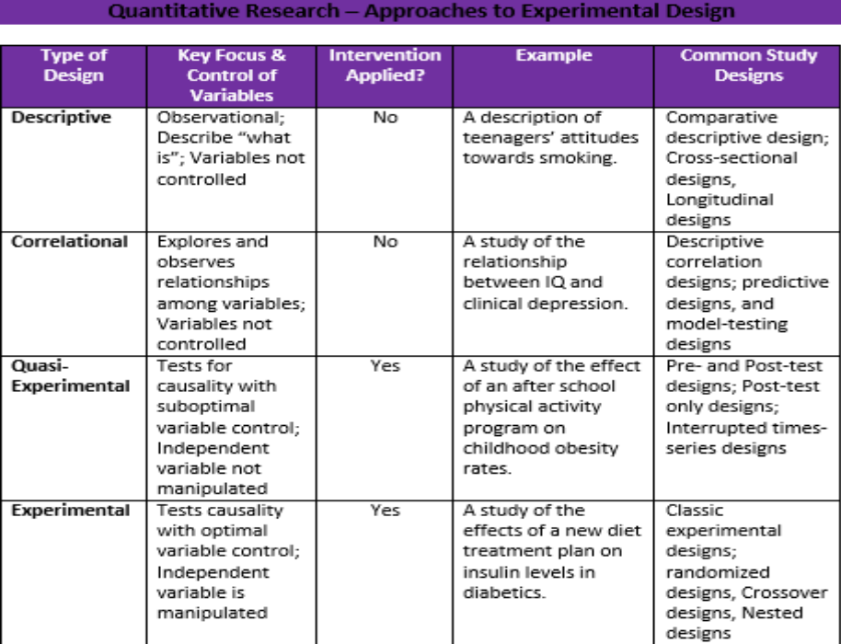

Literature review
What is a literature review?
•A place to make connections between what you are investigating and what has already been investigated in your subject area
•A place to engage in a type of conversation with other researchers in your subject area
•A place to identify previous research on the topic
•A place to show there is a gap in the literature which your study can fill
•A place from which to begin your own investigation
The „literature review‟ is the part of the thesis where there is extensive reference to related research and theory in your field; it is where connections are made between the source texts that you draw on and where you position yourself and your research among these sources.
Ridley, D. (2008). The literature review: A step-by-step guide for students. London: Sage Publications, p. 2.
It is your opportunity to engage in a written dialogue with researchers in your area while at the same time showing that you have engaged with, understood and responded to the relevant body of knowledge underpinning your research.
The literature review is where you identify the theories and previous research which have influenced your choice of research topic and the methodology you are choosing to adopt.
You can use the literature to support your identification of a problem to research and to illustrate that there is a gap in previous research which needs to be filled.
The literature review, therefore, serves as the driving force and jumping-off point for your own research investigation.
General Problems (Maddox & Liu)
•1. Some reviews consisted only of a largely unrelated annotated list of studies.
•2. Many of the studies listed in the reviews were not relevant to the new study.
•3. Many theories were mentioned or described in the reviews, but often without a clear, logical connection among the theories and without clearly pointing out the relevance of each description.
Answering general challenges
•Finding literature on your topic is only part of the process.
•What literature you do include must be relevant to your area of investigation.
•What pieces of the literature you do include must be logically connected to each other.

Challenges for students
•Language challenges –knowledge and proficiency in English at a high level
•Educational background challenges –how and when English was learned as an L2
•Cultural challenges –where English was learned as an L2
•Support challenges –what assistance is available for helping L2 learners improve their writing skills
•Limited vocabulary
•Sentence-level difficulties –aim for simple and clear
•Paraphrasing –when and how
Strategies (Qian& Krugley-Smolska)
•Reading and modeling –read many reviews by other researchers
•Planning –develop a writing plan before you start writing
•Using the L1 and translation –do not write in Chinese first and then simply translate into English
•Communication with the supervisor –seek advice and feedback
How to Begin?Finding Appropriate Sources of Information
•Know what is appropriate:
–Scholarly, academic, peer-reviewed material
–Material that presents empirical data/evidence to back up claims, not just opinions
–Material that presents an introduction, purpose, background literature, method, procedures, findings, discussion, implications, conclusion
•Know where to begin searching:
–Book catalogues
–Library databases –Education Research Complete, Education @ Scholars Portal, ERIC, Educational Administration Abstracts, Education: Sage Full-Text Collection
Use books as a beginning point
•Why books first?
•They gather a lot of information on one topic in one place.
•They can provide a good overview or good background information on a topic.
•They often offer extensive bibliographies.
Book Searching
•Our library catalogue -http://catalogue.library.brocku.ca/
•Other universities
•National Library
•WorldCat –http://www.worldcat.org
Look for journal articles second
•Journal articles discuss one perspective.
•Each article makes a unique contribution.
•Articles can supplement information found first in books.
•Articles can offer more up-to-date information.
Note on journal articles
•Don’t rely on one journal article to give you all the content points you want to cover.
Managing References
•Use RefWorks to build your own database of information.
•RefWorks holds citations and their links to the full text.
•You can create multiple folders in RefWorks.
•RefWorks allows you to create formatted bibliographies (APA, MLA, etc.).
•RefWorks allows you to create in-text references
Putting It All Together
•You have found a lot of literature
▫Now what?
•You need to organize what you have found:
▫By theme?
▫Chronologically?
•Tip: look at some examples
•It is your job to look at each journal article as one piece of information, and then to put all those pieces of information together.
•Putting the pieces together = making an argument
Another beginning point
•http://scholar.google.ca/
Caveats:
•Google Scholar does not have nearly the number of publisher agreements as are available through our 400+ library databases.
•Use the Get It @Brockoption to get back to full-text items from our databases (rather than going to a publisher’s page and paying them for information).
•Use Google Scholar
Citation chasing
•Searching from a known item (an article your professor gave you, the bibliography of a book on the topic)
•Find the bibliographic information for the item
•Cited Reference Searching -See who else may have cited it (Ebscodatabases like Education Research Complete, Web of Science, Google)
In-Text Citation Capitalization, Quotes, and Italics/UnderliningAlways capitalize proper nouns, including author names and initials: D. Jones. If you refer to the title of a source within your paper, capitalize all words that are four letters long or greater within the title of a source: Permanence and Change. Exceptions apply to short words that are verbs, nouns, pronouns, adjectives, and adverbs: Writing New Media, There Is Nothing Left to Lose. When capitalizing titles, capitalize both words in a hyphenated compound word: Natural-Born Cyborgs. Capitalize the first word after a dash or colon: "Defining Film Rhetoric: The Case of Hitchcock's Vertigo." Italicize or underline the titles of longer works such as books, edited collections, movies, television series, documentaries, or albums: The Closing of the American Mind; The Wizard of Oz; Friends. Put quotation marks around the titles of shorter works such as journal articles, articles from edited collections, television series episodes, and song titles: "Multimedia Narration: Constructing Possible Worlds"; "The One Where Chandler Can't Cry."
Short QuotationsIf you are directly quoting from a work, you will need to include the author, year of publication, and the page number for the reference (preceded by "p."). Introduce the quotation with a signal phrase that includes the author's last name followed by the date of publication in parentheses.According to Jones (1998), "Students often had difficulty using APA style, especially when it was their first time" (p. 199). Jones (1998) found "students often had difficulty using APA style" (p. 199); what implications does this have for teachers? If the author is not named in a signal phrase, place the author's last name, the year of publication, and the page number in parentheses after the quotation. She stated, "Students often had difficulty using APA style," (Jones, 1998, p. 199), but she did not offer an explanation as to why.
Long QuotationsPlace direct quotations longer than 40 words in a free-standing block of typewritten lines, and omit quotation marks. Start the quotation on a new line, indented five spaces from the left margin. Type the entire quotation on the new margin, and indent the first line of any subsequent paragraph within the quotation five spaces from the new margin. Maintain double-spacing throughout. The parenthetical citation should come after closing punctuation mark.Jones's (1998) study found the following: Students often had difficulty using APA style, especially when it was their first time citing sources. This difficulty could be attributed to the fact that many students failed to purchase a style manual or to ask their teacher for help. (p. 199)
Summary or Paraphrase If you are paraphrasing an idea from another work, you only have to make reference to the author and year of publication in your in-text reference, but APA guidelines encourage you to also provide the page number (although it is not required.)According to Jones (1998), APA style is a difficult citation format for first-time learners. APA style is a difficult citation format for first-time learners (Jones, 1998, p. 199).
Finding Your Voice
•Go with simplicity and clarity?
(“eschew obfuscation”)
•Author Strunk, William, 1869-1946.Title The elements of style / by William Strunk, Jr. ; with revisions, an introd., and a chapter on writing by E. B. White.Imprint New York : Macmillan, c1979. Edition 3d ed. –
Read “how to” manuals for ideas
•Author Dunleavy, Patrick.Title Authoring a PhD : how to plan, draft, write, and finish a doctoral thesis or dissertation / Patrick Dunleavy.Imprint Houndmills, Basingstoke, Hampshire ; New York : Palgrave Macmillan, 2003.
Learn from others and yourself
- Look at OWL example (referencing search).
- Take your own writing to a tutor/writing centre service.
- Ask your peers for comments; look at their writing.
- Study comments made on your own papers by your professors.
- Examine your professor’s writing.
- Practice, practice, practice, write, write, write!

Presenting your own voiceWhen writing your literature review, there are two main ways of presenting your own voice assertively. The first is by taking control of the text and leading your reader through the content... The second is by making your own position clear in relation to the source material that you incorporate and being explicit about how you will be drawing on particular aspects of previous work for your own research.
Ways of making your position clear
- Use the first person singular pronoun: “I,” “in my view”
- Use explicit transitions: “in direct contrast,” “in exactly the same way”
- Use strong adjectives: “insufficient,” “weak,” “supportive,” “most valuable”
- Ask yourself: Whose voice is strongest: mine or the authors I am citing?
Writing is a circular process
•Nothing will ever be perfect at any given moment in time.
•There is a constant need for improvement.
•Learn as you go along.
•Recognize what a good literature review may look like and strive to reach that goal.
Summary
- A literature review is a very important part of your thesis or dissertation.
- It grounds your study in the work of others.
- It shows how your study is connected to others.
- It displays a gap in the literature which you are attempting to fill.
- It sets the tone for the rest of your work.
Further Questions to Consider
•Is it ever appropriate to use non-scholarly material?
•Is it appropriate to include bachelors and masters theses or just doctoral dissertations?
•Do you need to include quotations in your literature review?
•Should you include statistics, data, government data, laws and regulations?
•What should you do if you are researching in an emergent area that does not have much literature?
•Do you need to balance books, journal articles, and theses?
•How far back in the literature do you need to go?
•When is enough enough?
•What is acceptable to your advisor?

Final Tips
•Keep a research journal –record what you have done, where you have looked, what searches you used, what you found.
•Searching keywords in titles can give you an overview of the literature, but searching controlled vocabulary in the databases will take you to the most focused results.
•Create a list of relevant keywords and subject terms to use.
•Always track the literature up until the completion of your first draft, but do a final search immediately prior to completing/defending your thesis.
•Have your research statement (questions) and nature of research (methodology) prior to diving straight into the literature.
For More Information
- Ridley, D. (2008). The literature review: A step-by-step guide for students. London: Sage Publications.
- Cooper, H.M. (1989). Integrating research: A guide for literature reviews. Beverly Hills: Sage Publications.
- Bell, J. (1993). Doing your research project: a guide for first-time researchers in education and social science. Buckingham, PA: Open University Press.
- Walliman, N.S. R. (2005). Your research project: A step-by-step guide for the first-time researcher. London: Sage Publications.

